Unveiling Waves-Typhoon Amplified Uncertainty of Offshore Wind Power Beyond Speed and its Propagation into Energy Systems Resilience
Zhijia Zhu, Haixin Wang, Member, IEEE, Bicheng Chen, Xinle Hu, Junyou Yang, Mingchao Xia,
Zhe Chen, Fellow, IEEE, Hassan Bevrani, Fellow, IEEE, Rui Jing

This Supplementary provides details for:
S.1 Select the best-fit Copula functions to evidence and describe the wind–wave correlation;
S.2 Simulate Typhoon–Wave interactions by Holland, SWAN, and their coupled model;
S.3 Capture the wave-induced wind speed variability by Wave-Driven Wind Model (WDWM);
S.4 The Scenario settings in the article;
S.5 Quantify wind uncertainty using an ambiguity uncertainty set based on Wasserstein distance;
S.6 Model of Distributionally Robust Optimization Multi-Energy System (DRO-MES).
S.7 Variables used in the Supplementary.

S.1 Select the best-fit Copula functions
This section evidences the correlation exist for wind and wave and explains why we choose t-Copula to describe the wind–wave correlation.
In this study, hourly wind speed and wave height data over three years for the offshore wind farm in Guangdong Province, China, are obtained. Based on these data, the probability density functions (PDF) for wind speed and wave height are first estimated separately, by applying the kernel density estimation (KDE) method. Let (x1,x2,…,xM) be the sample data of the variable X, Let the sample size be M. corresponding to a 24-hour observation period. The PDF is defined in Eq. (s1).
(s1)
where K() is the kernel function. In this study, the Gaussian kernel is adopted, i.e., $K(x)=\frac{1}{\sqrt{2π}}e^{-\frac{x^{2}}{2}}$; h is the bandwidth parameter that controls the smoothness of the curve. The value of h is calculated using the empirical formula in Eq. (s2).
(s2)
where σ is the standard deviation of the sample.
Based on the PDF, the corresponding cumulative distribution function (CDF) can be obtained by integrating the PDF. In practice, an empirical cumulative distribution function (ECDF) is constructed from the sample data to approximate this integral.
The variable X follows a probability density function g(x). If the order statistics satisfy (x1≤x2 ≤ … ≤xM ) then the ECDF GM(x)is defined as Eq. (s3):
(s3)
where k is the index of the sample data after sorting, and its value ranges from 1 to M−1.
Subsequently, the ECDF is transformed into a marginal distribution function. The marginal distribution function describes the distribution of a single variable without considering the influence of other variables. For a bivariate variable (X,Y), the marginal distribution function of X is denoted as $F_{X}(x)=P(xi≤x)$, and that of Y is denoted as $F_{Y}(y)=P(yi≤y).$
Then, we use the Copula functions to combine the marginal distribution functions of multiple variables to construct their joint distribution, thereby characterizing the correlation among variables. Commonly used Copula functions include the Gumbel Copula, Clayton Copula, Frank Copula, Gaussian Copula, and t-Copula. To identify the best fit Copula function, the Kendall's rank (τ) and Spearman's rank (ρs) correlation coefficients, along with the Euclidean distances of various Copula functions are calculated and further compared with the empirical values obtained from the sample data.
The formulas for calculating Kendall’s τ and Spearman’s ρs are presented in Eq. (s4) and (s5), respectively. A positive τ indicates a positive correlation between the variables. Spearman’s ρs measures the strength of the monotonic correlation between variables, with higher values indicating stronger monotonic correlation. In this study, we assume that S is wind speed and H is wave height. An array (S,H) is constructed with a series of pairs.
(s4)
(s5)
where a is the number of sample pairs exhibiting the same trend of variation, b represents the number of sample pairs exhibiting opposite trends, M is the total number of sampling points, ci represents the rank of the wind speed sample (S1,S2,…,SM) and di represents the rank of the wave height sample (d1, d2,…, dM), and are the mean rank values, respectively.
The Euclidean distances of various Copula functions are calculated as defined in Eq. (s6). A smaller Euclidean distance indicates a better fit of the corresponding Copula function.
(s6)
where s_{i}∗ and h_{i}*are the standardized sample values.
The performance of different Copula functions are fitted and presented in Table s1. A stronger correlation is indicated by correlation coefficients closer to 1 and Euclidean distances closer to 0.
Table s1 The coefficients and squared Euclidean distances of various Copula functions
Copula Type | Euclidean Distance | Kendall | Spearman
Sample Data | 0 | 0.54093 | 0.73377
Gaussian | 0.053434 | 1 | 1
t-copula | 0.052875 | 1 | 1
Gumbel | 0.24747 | 0.50947 | 0.69318
Clayton | 0.85728 | 0.40312 | 0.56786
Frank | 0.13755 | 0.53693 | 0.73602

As shown in Table s1, the t-copula’s Kendall's and Spearman's rank correlation coefficients both equal to 1, and becomes the best fit copula with the smallest Euclidean distance. As illustrated in Figure s1(c), the t-copula captures the tail correlation between wind speed and wave height, accurately reflecting the physical characteristic that higher wind speeds tend to generate higher waves. Although the Gaussian copula also has good correlation in terms of correlation coefficients, its Euclidean distance is slightly larger than that of the t-copula, indicating slightly lower fitting accuracy. In contrast, the Clayton copula shows the largest deviation from a correlation coefficient of 1 and has the largest Euclidean distance, indicating the poorest fitting performance. The Clayton copula is depicts lower-tail correlation between variables, as shown in Figure s1(d), whereas the correlation between wind speed and wave height is mainly concentrated in the upper tail (i.e., extremely high wind speeds are often accompanied by extremely high waves).
Therefore, the t-copula was adopted in this study to characterize the correlation between wind speed and wave height. The joint CDF of the t-copula is given in Eq. (s7).
(s7)
where u₁ and u₂ represent the marginal distribution values of wind speed and wave height, respectively; V_{t} is the degrees of freedom parameter, with smaller values indicating heavier tails; ∑ and is the covariance matrix that describes the correlation between variables.
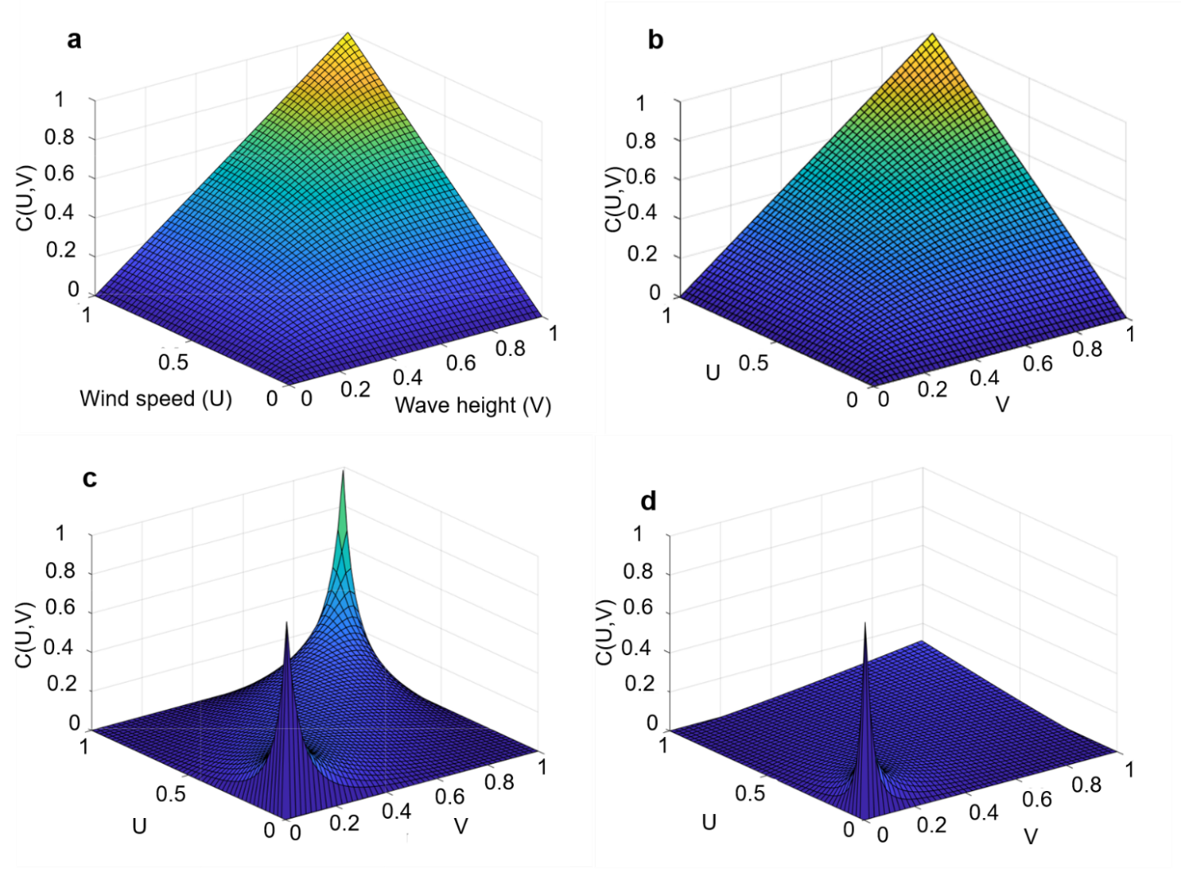
Figure s1 Comparison for t-Copula and Clayton -Copula functions. a t-copula joint CDF, b Clayton -copula joint CDF c t-copula joint PDF d Clayton -copula joint PDF

S.2 Holland-SWAN Coupled model for Typhoon–Wave simulation
The theoretical basis for wind–wave coupling is briefed in S.2.1 and Holland-SWAN Coupled model is described in S.2.2.

S.2.1 Mechanisms of wind–wave coupling
As the critical transitional zone between the ocean and atmosphere, the air–sea interface exhibits multi-scale coupled dynamic processes. This interface links the atmospheric boundary layer (ABL) with the marine boundary layer (MBL) and is in a state of dynamic energy equilibrium constantly. When wind blows over the sea surface, it initially induces small perturbations through friction. As the wind speed increases and persists, energy is gradually transferred into the wave field, leading to continuous wave growth. This process is primarily mediated by wind stress, which is often quantified through the drag coefficient, as expressed in Eq. (s8):
(s8)
where τ_{s} is the wind stress, representing the tangential force per unit area exerted on the sea surface; C_{d} is the drag coefficient, ρ_{air} is the air density, and U₁₀ is the wind speed at 10 meters height (in m/s).
According to the [1], [2], the wind stress τ_{s} can be decomposed into the viscous component τ_{vis}, the turbulent-associated component τ_{turb}, and the component related to air movement caused by waves τ_{wave}, as expressed in Eq. (s9).
(s9)
where τ_{wave}>0 indicates that the wave absorbs energy from the wind; conversely, τ_{wave}<0 implies the wave transfers energy back to the wind, thereby accelerating the wind speed.
The magnitude of wind stress directly affects the energy exchange between waves and wind speed, while the three parameters of wave age, significant wave height (one-third of the highest waves), and swell propagation direction jointly determine the magnitude and direction of wave-coherent wind stress, thereby influencing the magnitude and direction of total wind stress. Under swell-dominated conditions, when the wave age is large, the significant wave height is high, and the swells are aligned with the wind direction, the wave-coherent wind stress may oppose the wind direction, thereby reducing the total wind stress. When the swells are opposite to the wind direction, the wave-coherent wind stress aligns with the wind direction, thereby enhancing the total wind stress.
The wave age, typically denoted as $\hat{U}$ is defined as the ratio between the waves phase speed and the wind speed as shown in Eq (s10). Wave age reflects the maturity of the waves. A higher wave age typically indicates that the waves have developed more maturely, during which more energy is transferred back to the wind, potentially increasing wind speed. In contrast, a lower wave age indicates that the waves are relatively young and in their growth phase, requiring energy absorption from the wind, which is more likely to result in a decrease in wind speed.
(s10)
where U represents the wind speed; θ_{p} is the angle between the wave propagation direction and the wind direction; and C_{p} is the wave phase speed. For more detailed information on wind stress and wave age, please refer to the literature [3], [4].
Wu et al. [5] , using the Large-Eddy Simulation (LES) confirmed that the presence of swells significantly alters the wind speed profile, i.e., a phenomenon referred to as wave-driven wind, particularly in the lower regions near the sea surface. Compared to conditions without swells, the disturbances caused by swells make the wind speed profile steeper, especially in the crest regions, which further enhances the variation of wind speed with height.
Figure s2(a) shows the correlation between the normalized wind speed at 30 meters [U/U (30)] and the ABL height Z [m] based on measured data. z/λ represents the ratio of the ABL height to the wavelength. The square curve in black represents the wind speed profile under flat land terrain conditions. It can be observed that the wind speed follows a logarithmic relationship with height. The blue triangle curve represents the wind speed, which begins to increase under the influence of swells, in conditions of growing sea and ocean-atmosphere convection. The red circular curve represents the wind speed under low wind conditions (about 1.4 m/s) with strong swells, where the wind speed reaches its maximum near 8 meters. The green triangle curve corresponds to the wind behaviour with weak swells and a wind speed of 4.7 m/s, where the wind speed gradually stabilizes as the height increases. The LES simulation results in Figure s2(b) evidenced the phenomenon [6].
In addition, waves, by influence wind speed, further influence the output power of wind turbines. Therefore, Alsam et al. [7] employed LES combined with actuator-line techniques to investigate the influence of swells on the power output of offshore wind turbines. The results showed that under the same wind speed, the presence of swell significantly enhanced power generation. Specifically, when the wave age was 1.54, power output increased by approximately 3%, and when the wave age reached 2.17, the increase was about 8.4%. This improvement was primarily attributed to the ability of swell to reduce the total wind stress, thereby increasing wind speed, decreasing wind shear, and decreasing turbulence intensity, which led to a higher power efficiency.
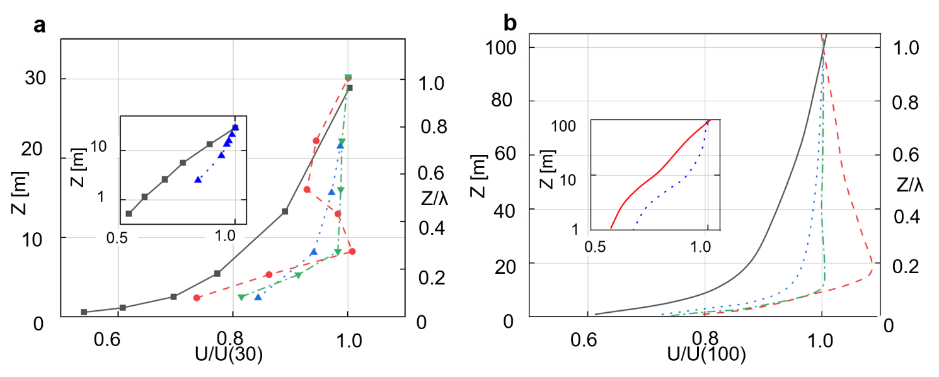
Figure s2. a Measured Vertical Wind Profiles: The black squares represent no swells and neutral conditions; blue triangles represent a growing sea under convective conditions; red circles represent swells during low wind speed (about 1.4 m s⁻¹) under near-neutral conditions; green triangles represent swells during moderate wind speed (about 4.7 m s⁻¹) under convective conditions. b LES Simulated Vertical Wind Profiles: The black solid line represents no swells and neutral conditions; blue dashed line represents no swells and convective conditions; red dashed line represents swells and neutral conditions; green dashed line represents swells and convective conditions. For more detailed information please refer to the literature [5], [6].

S.2.2 Holland typhoon model
To capture the typhoon-induced extreme wind, the triggered massive waves, and the complex interaction between wind-wave, we developed a Holland–SWAN Model, among which the Holland typhoon model is firstly detailed below.
The Holland model is based on the principle of gradient wind balance and is used to describe the pressure distribution and wind speed variation within a typhoon. To apply the Holland model for calculating typhoon-induced pressure and wind speed, key input parameters, i.e., the radius of maximum wind (R_{max}), maximum sustained wind speed, and central pressure (P_{c}) are used.
Assuming the typhoon pressure exhibits axial symmetry, with pressure gradually increasing from the center outward, it can be described by the following Eq. (s11).
(s11)
where P_{n} is the ambient pressure outside the typhoon, R_{max} represents the radius of maximum wind, and B is the Holland parameter. r is the radial distance from the typhoon center Generally,
Then, the tangential wind speed can be derived based on the gradient wind balance Eq. (s12).
(s12)
where 𝜌_{air} is the air density, taken as 1.15 kg/m³, and 𝑓 is the Coriolis parameter ($f=2Ω\sin{φ}$), which is dependent on the latitude φ. The correlation between typhoon wind speed, the radial distance from the typhoon center, and the typhoon intensity in the Holland model can be expressed by Eq. (s13), also known as Eq. (1) in the main text.
(s13)
where V(r) is the wind speed (in m/s) at a radial distance r, Vm is the maximum wind speed at the typhoon center, The parameters d and e are empirical coefficients, typically ranging between 1 and 2.

S.2.3 SWAN model
The Simulating Waves Nearshore (SWAN) model is constructed to calculate the evolution of waves in nearshore and inland waters. In the Cartesian coordinate system, the equation is expressed as Eq. (s14) [8], also known as Eq. (2) in the main text.
(s14)
where N is the wave spectrum density (m²/Hz⋅ rad); C_{x}, C_{y}, C_{γ} and C_{θ} are the propagation speed of wave in physical space (x, y) , relative frequency space γ, and directional space θ (m/s); γ is the relative frequency (Hz), and θ is the wave propagation direction; S is the source term, including wind energy input, and nonlinear wave–wave interactions, which together represent the energy exchange mechanisms within the wave field. The complete formulation is given in Eq. (s15⁾ [9], also known as Eq. (3) in the main text.
(s15)
where S_{in} is the wind energy input, describing the energy transferred to waves through wind forcing, S_{nl} is the nonlinear interactions, respectively. The dissipation terms S_{ds,w}, S_{ds,b}, S_{ds,br} correspond to whitecapping breaking, bottom friction dissipation, and depth-induced breaking, respectively; each accounting for energy loss due to physical wave processes [10]. More details are further elaborated below.
As shown in Eq. (s15), the wind energy input S_{in}(γ,θ) in the SWAN model can be expressed as Eq (s16).
(s16)
where β is the wave growth coefficient, typically ranging from 0.01 to 0.05; u* is the friction velocity (m/s); g is the gravitational acceleration (9.8 m/s²); E(γ,θ) is the wave energy density spectrum, representing the distribution of energy across frequency γ and direction θ. The bottom friction dissipation term S_{ds,b}(γ,θ) is given by Eq. (s17):
(s17)
where C_{bot} is the bottom friction coefficient, typically ranging from 0.001 to 0.1, depending on the seabed roughness. 𝜌_{water} and 𝜌_{air} represent the densities of water and air, respectively. The depth-induced breaking dissipation term S_{ds,br}(γ,θ) is expressed as Eq. (s18):
(s18)
where α_{br} is the dissipation coefficient for depth-induced breaking; The breaking index is represented by, ξ_{br}, and the breaking probability density Q_{br} is calculated based on wave height H and water depth d. The formulation is as Eq. (s19):
(s19)

S.2.4 Holland–SWAN Coupled Model
Based on above, the Holland–SWAN coupled typhoon–wave model was employed to simulate the wave heights generated by Typhoon Chaba (No. 2203) in 2022. Chaba developed over the South China Sea at 08:00 on June 29, 2022, and moved northwestward. After 24 hours, it intensified from a tropical depression into a tropical storm and continued to strengthen. By 23:00 on July 1, it evolved into a typhoon and approached the Greater Bay Area (GBA) with a maximum central wind speed of 38 m/s. On July 2, Typhoon Chaba made landfall in Dianbai District, Maoming City, with a maximum wind speed of 35 m/s (Category 12). Accordingly, this study defined the potentially affected simulation geographical range within the coordinates 107°E–118°E longitude and 12.5°N–24.5°N latitude. The simulation period was set from 00:00 on July 1 to 18:00 on July 3, totaling 66 hours. The typhoon wind field was updated at 6-hour intervals.
The key typhoon parameters required for Holland typhoon model, i.e., maximum wind speed, radius of maximum wind, translation speed, and typhoon center longitude and latitude, were obtained from the China Meteorological Administration [https://typhoon.nmc.cn/web.html]. In this study, these parameters were input into the Holland typhoon model to calculate the wind speed. The simulated wind speed output, shown in Figure s3, is used as input for the SWAN wave model to simulate the wave height under typhoon conditions. Figure s4a shows the spatial distribution of wave height during the typhoon condition. The simulation results show that, under sustained high wind speeds of Chaba, the maximum wave height in the study area reached 10 meters. From Figure s3 and Figure s4a, the spatial distribution of wave height shows a strong correlation with the distribution of typhoon wind speed.
For validation, the historical wave height data for the same study period (00:00 on July 1 to 18:00 on July 3) were obtained from the ERA5 reanalysis dataset provided by the ECMWF (www.ecmwf.int), as shown in Figure s4b. It is validated that Figure s4a and s4b show similar wave height distribution across the studies area. Note that the simulated wave height could be higher in Figure s4a as the Holland–SWAN Coupled Model could better capture the typhoon-wave coupling at a finer temporal granularity (i.e., 30-minute resolution), whereas the wave height data from ERA5 is characterized by hourly resolution.
In summary, under typhoon condition, there is a stronger correlation between wind speed and wave height, the energy exchange between wind and waves becomes more intense, not only induce a higher wave height, but also significantly increases the uncertainty of wind speed.
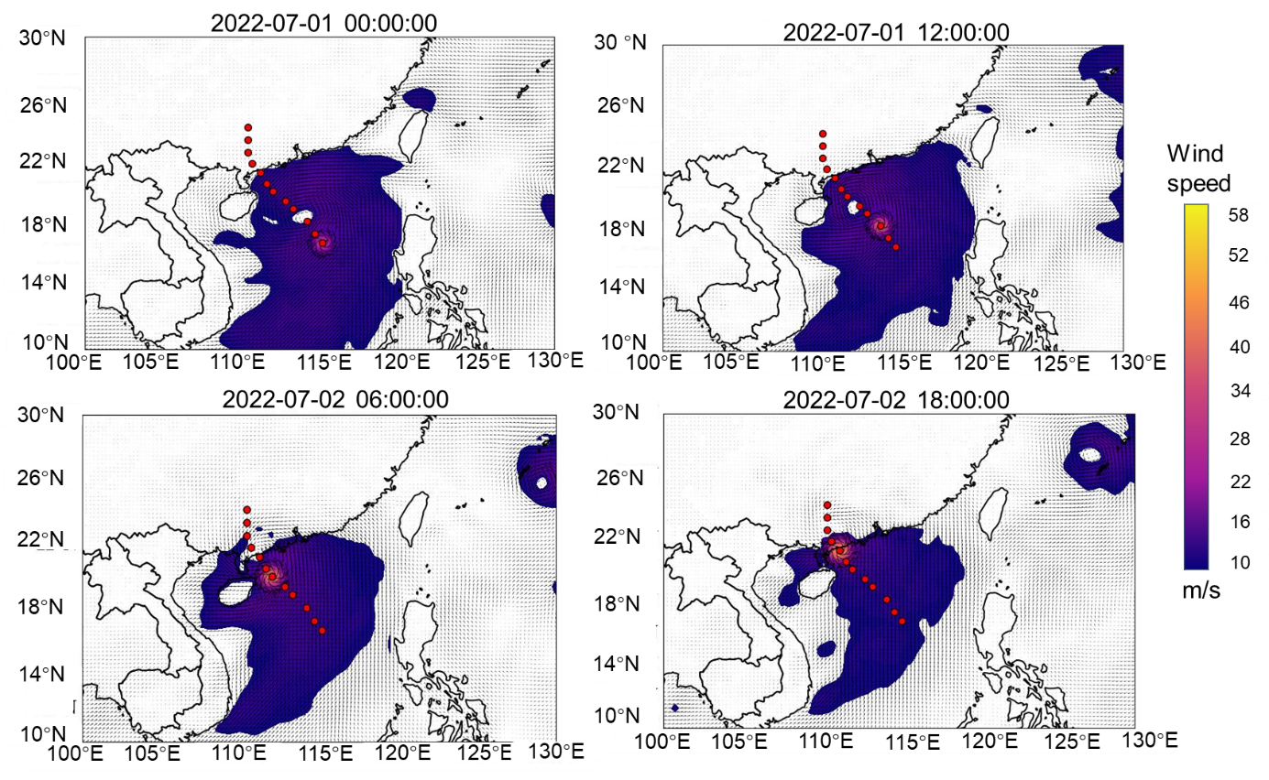
Figure s3 Simulated wind speeds for Typhoon Chaba from the Holland typhoon model

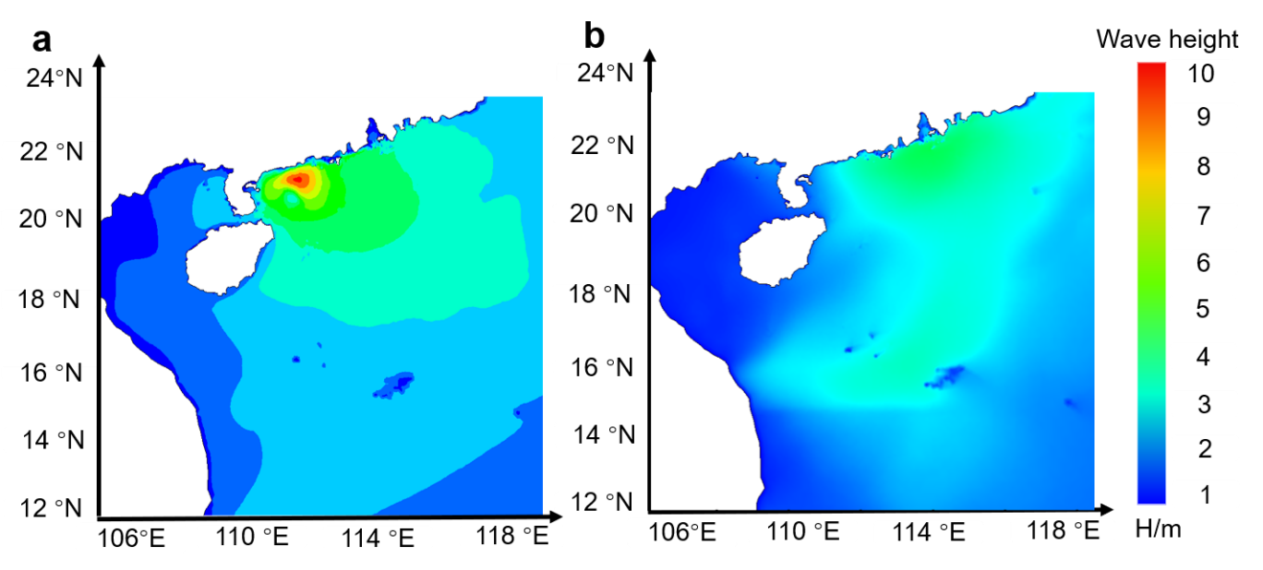
Figure s4 Typhoon–Wave Coupled Simulation results. a Simulated wave height considering typhoon-wave coupling, b Historical wave height not considering typhoon-wave coupling.

S.3 Wave-Driven Wind Model (WDWM)
We constructed the Wave-Driven Wind Model (WDWM) to capture the wave-induced wind speed variability under varying wave conditions, and incorporates the Charnock parameter to estimate the sea surface roughness length z₀. The formulation used for calculating the roughness length is provided in Eq. (s20) [11].
(s20)
where u∗ is the friction velocity, and v_{water} is the kinematic viscosity of water, taken as 1.4×10⁻⁵ m²/s. α_{ch} is the Charnock parameter. The first term in the formula, $α_{ch}u_{*}^{2}/g$ represents the correlation between wind speed and gravity, reflecting the effect of wind speed on sea surface roughness. The second term, $0.11v/u_{*}$, accounts for the molecular viscosity of air. It plays a certain corrective role for wind speed variations. It is important to note that the Charnock parameter α_{ch} is not a constant, but rather dependent on wave stress (wave-induced momentum flux) [12]. In this study, the ERA5 hourly reanalysis Charnock dataset is used to obtain the necessary input parameters. α_{ch} calculation is shown in Eq (s21).
(s21)
where, τ_{s} is the total surface wind stress and τ_{wave} represents the wave stress. The friction velocity can be expressed as Eq (s22):
(s22)
The momentum exchange between air and water can be described by the drag coefficient C_{d}, and the specific relationship is given as Eq.(s23):
(s23)
Based on the above formulation, the momentum exchange between air and water can be expressed in terms of the friction velocity u∗, thereby enhancing the accuracy of wind profile predictions. To analyze the variation of wind speed with height, the logarithmic wind profile model is commonly employed to describe wind distribution in the ABL. This model assumes that, under idealized conditions, there exists a logarithmic relationship between wind speed and height z. The corresponding expression is provided in Eq. (s24).
(s24)
where, z is the vertical height above the ground surface, 𝜅=0.4 is the von Kármán constant, which can provide a more accurate depiction of wind speed variations due to the interaction between waves and wind. Since the ERA5 raw wind is based on atmospheric reanalysis, relying mainly on atmospheric observations and model simulations, the impact of waves on wind speed is primarily reflected in the friction between the wind and waves. This frictional change can cause fluctuations in wind speed. However, the raw wind does not account for the interaction between waves and wind, and therefore, it does not accurately reflect the impact of waves on wind speed. In contrast, the WDWM considers the interaction between waves and wind, generating wind speed profiles that show a similar distribution to raw wind speeds, but with slightly more intense fluctuations, as shown in Figure s5.
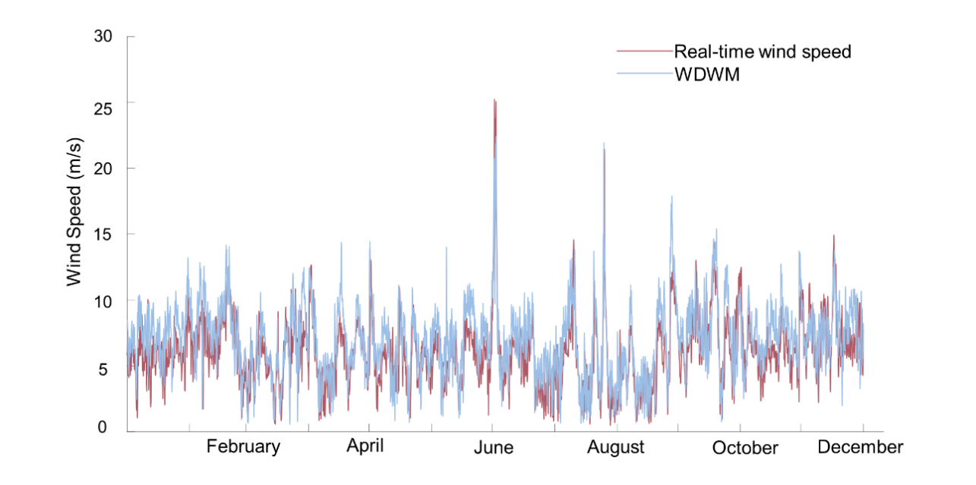
Figure s5 Comparison between WDWM generated and Historical Wind Speed Profiles.

Townsend et al. [13] provided an in-depth analysis of the enhanced wind speed profile caused by wave–wind interactions, and experimentally quantified their influence on wind speed at various heights along a wind turbine blade. These findings demonstrate that wave-induced disturbances can significantly influence wind resource availability at different vertical positions along the rotor plane of wind turbines. Figure s6 illustrates the mean streamwise velocity profiles within the ABL under different wind–wave interaction conditions. This figure compares representative cases with varying wave heights (H) and wavelengths (λ) to highlight the influence of wave-induced effects. The blue dashed line is the incident Computational Fluid Dynamics (CFD) ABL profile, which represents the original inlet wind velocity distribution obtained from the CFD simulation prior to accounting for wave effects. The red dotted line represents the averaged ABL, which indicates the representative wind speed profile obtained by sample averaging under identical conditions, serving as a baseline for comparison. The green line represents the re-calibrated atmospheric boundary layer (Re-calibrated ABL), in which the power exponent (α) is introduced to adjust the vertical gradient of the wind speed profile, and the wind risk factor (k_{f}) is applied to modify the overall wind speed magnitude, thereby providing a more realistic representation of the wind–wave interaction effects on the ABL wind structure. Hence, Figure s6 indicates that when the significant wave height was 0.3 m and the wavelength was 3 m, the wind speeds at the lowest blade nadir, the hub height, and the blade zenith increased by 10.1%, 3.1%, and 1.3%, respectively.
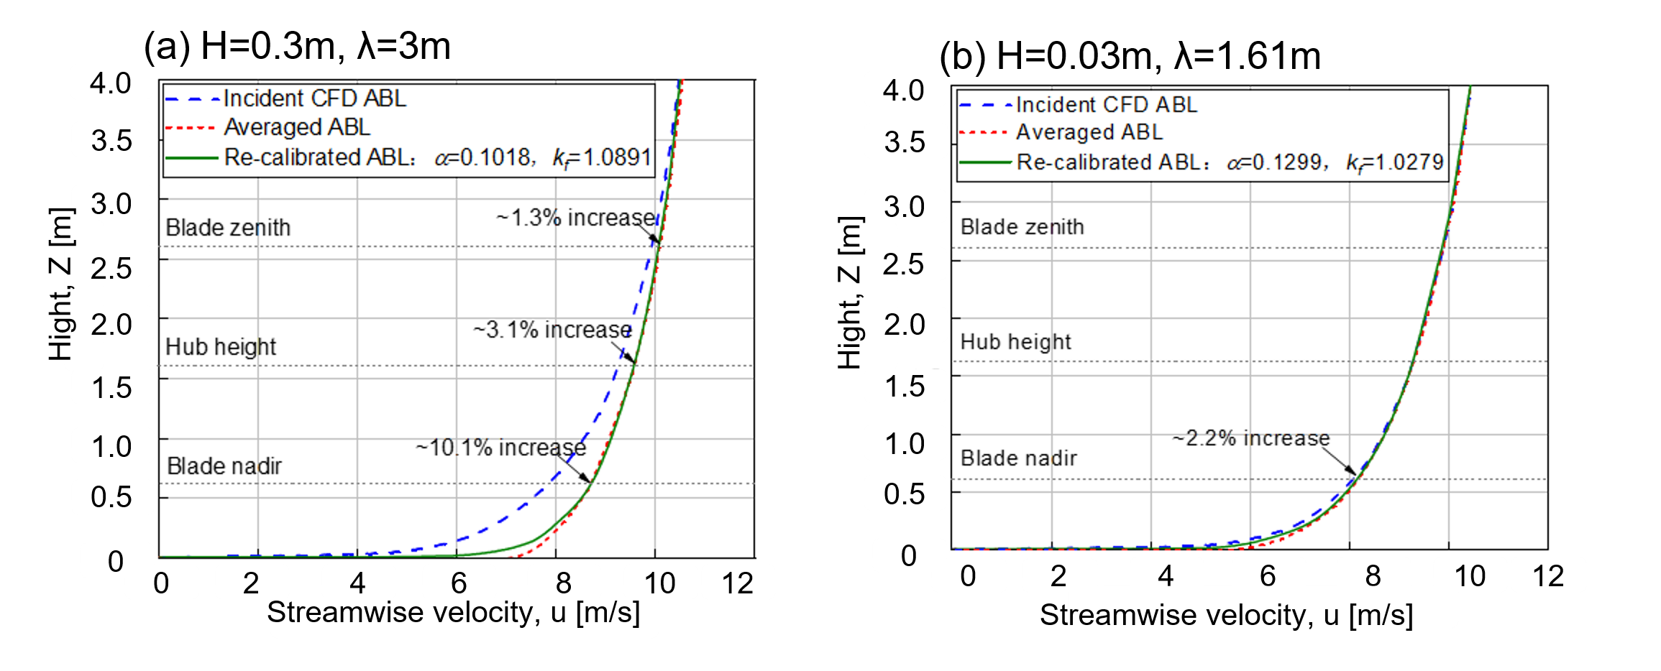
Figure s6 Wind Speed Variation at Different Rotor Heights under Wave–Wind Interaction[13]

Based on the findings from reference [13], the wind speed increases by different percentages under various significant wave heights (0.3 m and 0.03 m) and wavelengths (3 m and 1.61 m).
In this study, numerical results indicate that wave-induced wind speed increments range from ~1.3% to ~10.1% along the wind turbine height. Considering that the blade nadir region is more sensitive to surface wave effects and turbulence, and typically exhibits a relatively low wind speed, the 10.1% increase was chosen for detailed analysis. Based on this increment, the final wind speed under wave-induced is then calculated using the adjustment Eq. (s25).
(s25)
where u_{f}(z) represents the wave-driven wind speed, while u_{ac}(z) is the measured wind speed at 10 m height, β is set to 10.1%.

S.4 Scenario settings
When setting up scenarios, we considered the influence of typhoon conditions and normal conditions on the MES. We use the Typhoon-Wave Evolution Dataset (TWED), as simulated in section S.2, as input for the typhoon scenes. Meanwhile, the wind speed dataset driven by wave, generated by the WDWM introduced in section S3, covering a time span from 2022 to 2024. This dataset, characterized by a 3-year scale and a broad range of scenarios, is subjected to K-medoids clustering to generate conventional scenarios.
Considering the distinct seasonal variations in wind speeds in GBA, we further improve the clustering process. In specific, during the summer, when there is no typhoon, the influence of tropical high pressure often results in low wind speeds. Before the arrival of a typhoon, wind speeds frequently exceed 10 m/s (medium wind speed) due to the influence of the typhoon. Additionally, in the winter, the wind speeds near the Taiwan Strait exit are typically higher due to the winter monsoon. Therefore, two different wind speed scenarios are clustered: one for low wind speeds in summer, medium wind speeds in summer and winter. The two types of wind speed are shown in Figure s7. Based on wind speed intensity, wave levels, grid connectivity condition, and seasonal load types, a total of six representative scenarios is constructed as listed in Table 1 in the main text.
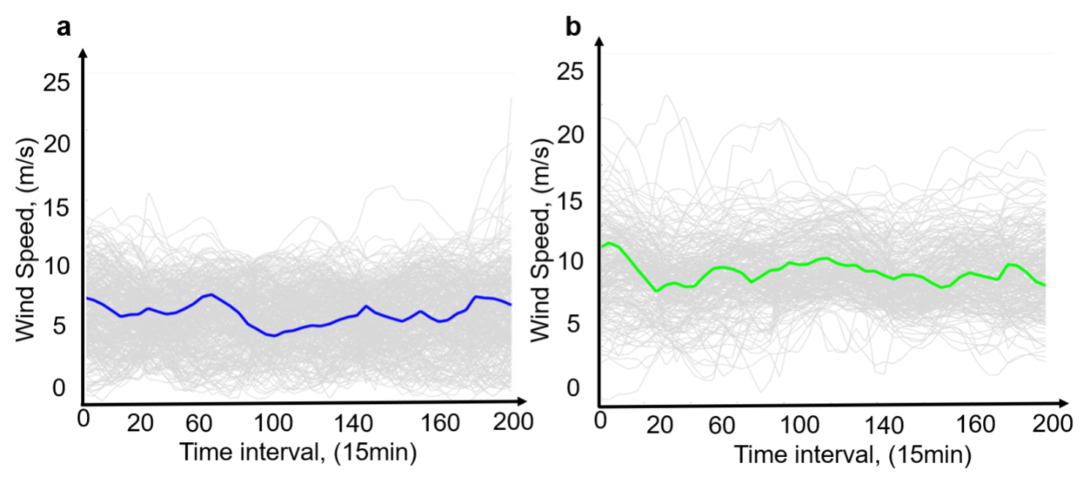
Figure s7 The two types of wind speed. a. Low wind speed, b. Medium wind speed.

S.5 Wasserstein-based wind uncertainty distribution
In this section, the uncertainty of offshore wind power output is modeled using an ambiguity uncertainty set based on the Wasserstein distance. Specifically, a data-driven ambiguity set for offshore wind power is constructed using the three-year wave-driven wind speed dataset generated in Section S.3. This uncertainty set captures plausible probability distributions under a given confidence level, thereby decreasing the over-conservatism often encountered in traditional robust optimization frameworks.

S.5.1 Wasserstein distance-based wind power uncertainty modeling
The prediction error between the predicted and actual wind power output at instance ${\tilde{ξ}}_{i}$ is denoted as Eq.(s26):
(s26)
where${\hat{ P}}_{i}^{w}$ and ${\tilde{P}}_{i}^{w}$represent the predicted and actual output of offshore wind power, respectively. In this study, the output deviation $\tilde{ξ }$is a variable. Assuming the probability distribution of $\tilde{ξ }$is unknown but that a set of M independent and identically distributed historical samples is available, $\{{\tilde{ξ}}_{1},{\tilde{ξ}}_{2}, …,{\tilde{ξ}}_{M}\}$,the empirical distribution Q_{N} can be used to estimate the true distribution $P$ of $\tilde{ξ }$, as Eq.(s27) [14], [15].
(s27)
where, $δ_{{\overset{ˉ}{ξ}}_{i}}$ is the Dirac measure, which indicates the presence of sample point ${\overset{ˉ}{ξ}}_{i}$in the sample set. Specifically, $δ_{{\overset{ˉ}{ξ}}_{i}}=1$if the point belongs to the set, and $δ_{{\overset{ˉ}{ξ}}_{i}}=0$ otherwise.
The DRO ambiguity set based on Wasserstein distance is centered on the empirical distribution of the uncertain random variable $\tilde{ξ }$, using Q_{N} as an estimate of the unknown true distribution P. Then, based on Q_{N}, an ambiguity set that potentially contains P is constructed, satisfying the convergence condition: $\lim_{M→∞}Q_{N}=P$, To formalize the closeness between Q_{N} and $P$ the Wasserstein distance is introduced. The Wasserstein distance is given as Eq.(s28):
(s28)
where ${\tilde{ξ}}_{M}$and $\tilde{ξ}$ are uncertain parameters drawn from the empirical distribution Q_{N} and the true distribution P, respectively. Π represents a joint probability measure with marginals Q_{N} and $P$. The function $d\left({\tilde{ξ}}_{M},\tilde{ξ}\right)=∥{\tilde{ξ}}_{M}-\tilde{ξ}∥$ describes the transportation cost between distributions, i.e., the effort required to transfer mass from $P$ to Q_{N}. Thus, the Wasserstein distance quantifies the minimum total cost needed to transform one distribution into another [15]. Based on this, the ambiguity set can be defined as Eq.(s29):
(s29)
This ambiguity set in Eq.(s29) can be viewed as a Wasserstein ball centered at Q_{N} with radius ε(M). The radius reflects the confidence level in approximating the true distribution, and is linked to the sample size M. The radius function is expressed as Eq.(s30) and Eq.(s31):
(s30)
(s31)
where, 1-β₁ represents the confidence level associated with the radius of the Wasserstein ball; ${\overset{ˉ}{ξ}}^{ti}$ is the mean of all samples; ∂ is parameter; and ${\overset{ˉ}{ξ}}_{M}$ is the M-th uncertain parameter. It can be observed that as the radius of the Wasserstein ball increases, the ambiguity set $A$ expands, thereby covering a broader range of uncertain distributions [16].

S.5.2 Data-driven support set
In this context, the ambiguity set is defined over a specific domain, where the support set Ξ represents the set of all points in that domain with a non-zero membership grade. According to references[15], [17], the support set Ξ can be constructed using the sample data $\{{\tilde{ξ}}_{1},{\tilde{ξ}}_{2},…,{\tilde{ξ}}_{M}\}$. The sample set is first standardized using normalization as Eq.(s32):
(s32)
where $∑$ is the sample covariance matrix, and ${\tilde{ξ}}_{i}$ is the i-th sample. After normalization, the uncertain parameter samples θ_{i}^{u} have zero mean and unit variance. Let Φ be the support set of θ_{i}^{u}, as defined in Eq.(s33):
(s33)
where θ_{i} is the i-th element in θ^{u}. and l represents the boundary of θ_{i}. R is the set of real numbers.
Therefore, the goal of constructing the set Φ is to determine a reasonable parameter l, such that on one hand, the event for the random variable θ_{i} occurs with high probability, and on the other hand, the size of the support set Φ is kept as small as possible to enhance the conservativeness of the model. To this end, the optimization problem for l is formulated as Eq.(s34):
(s34)
where l_{max} is the upper bound of l; p^{std} and $A^{std}$ represent the probability distribution and ambiguity set of the standardized uncertain parameter θ^{u}, respectively. Once the optimal l is determined, the data-driven support set Ξ can be obtained as Eq.(s35):
(s35)

S.6 DRO-MES model formulation
The mathematic formulation for the Wasserstein-based Distributionally Robust Optimization Multi-Energy System (DRO-MES) optimization model is explicated here. S.6.1 firstly defined all the sets and variables in the model.

S.6.1 First-stage objective function and constraints
The DRO-MES optimization model’s first-stage objective function and constraints are derived below.

S.6.1.1 First-Stage objective function
The objective function is to minimize the total operating cost (TOC) of WSDRO-MES, which considers the equipment operation cost C_{ope}, electricity purchase cost C_{e}^{buy}, natural gas purchase cost C_{g}^{buy}, and the regulation cost caused by offshore wind power fluctuation $\sup_{P∈A}E_{P}(Q(x,\tilde{ξ}))$ as shown by Eq. (s36).
(s36)
where C_{e}^{buy}, C_{g}^{buy}, C_{ope} are further derived in Eq. (s37) ~ (s39).
(s37)
where λ_{e,t}^{buy} is the unit price of purchasing electricity from the power grid and P_{grid,t}^{buy} is the amount of electricity purchased from the power grid.
(s38)
where, λ_{g}^{buy} is the unit price of purchasing gas from the gas network and P_{gas,t}^{buy} is gas volume purchased from the gas network.
(s39)
where C_{CHP}, C_{GB}, C_{HP}, C_{AC} and C_{BESS} are operation and maintenance costs of the CHP, gas boiler, heat pump, Absorption chiller and battery energy storage system (BESS), respectively.

S.6.1.2 First-stage constraints
Energy balance constraints. Electricity, heating and cooling balances are modeled. The heating balance is presented in Eq. (s40).
(s40)
where t is the time interval, and in this study, the dispatch time spans 48 hours with a 15-minute interval. H_{t}^{CHP} is output of the CHP at time t; H_{t}^{GB} denotes the heating output of the gas boiler at time t; H_{t}^{load} is the heating load; H_{t}^{HP} is the heating supply from heat pump, H_{t}^{AC} is the heating consumed by absorption chiller.
Eq. (s41) shows the electricity balance.
(s41)
where P_{t}^{buy} is the electricity purchased from the power grid; P_{t}^{PV} is the Photovoltaic power generation; P_{t}^{w} is the wind output; P_{t}^{CHP} is the electricity output of the CHP; P_{t}^{cha} and P_{t} ^{dis} denote the charging and discharging power at time t; P_{t}^{load} is the electricity load; P_{t}^{HP} is the electricity consumed by heat pumps.
Eq. (s42) shows the cooling balance.
(s42)
where C_{t}^{HP} is the cooling supplied by heat pump, C_{t}^{AC} is the cooling supplied by absorption chiller, C_{t}^{load} is the cooling load.
Operational constraints. The heat pump, PV, WT, CHP, gas boiler, and absorption chiller energy conversion constraints are shown by Eq. (S43a~g). WT installation areas have a physical limit as constrained in Eq. (S43h).
(S43a)
(S43b)
(S43c)
(S43d)
(S43e)
(S43f)
(S43g)
(S43h)
where η_{hp,c} η_{hp,h} are the coefficients of performance (COP) in cooling and heating modes, respectively; P_{out}^{w} denote rated power output of the offshore wind turbine, V_{wind} denote actual wind speed, V_{in} and V_{out} denote cut-in (3m/s) and cut-out wind speeds (25m/s) respectively, ρ_{air} is air density, C_{p} is aerodynamic power coefficient; G_{t}^{CHP} represents the natural gas consumption rate of the CHP at time t; η_{chp,e} and η_{chp,h} denote the electrical efficiency and thermal efficiency of the CHP, respectively; λ_{CH4} is the lower heating value (LHV) of natural gas, the lower heating value of natural gas is taken as 9.78 kWh/m³, G_{t}^{GB} represents the natural gas consumption rate of the gas boiler at time t, η_{GB,h} is the thermal efficiency of the gas boiler; η_{t}^{AC} is the thermal-to-cooling conversion efficiency; P^{w}_{t,max} is the maximum wind power output of the wind farm.
Battery storage constraints. Battery storage is modeled as in Eq. (S44a~e).
(S44a)
(S44b)
(S44c)
(S44d)
(S44e)
where P_{max}^{dis} and P_{min}^{cha} are denote the upper bounds of charging and discharging power, respectively; u_{t} is the binary state variable indicating the charging or discharging status of the battery (0 or 1), u is the self-discharge rate of the battery storage system, E_{min} and E_{max} represent the minimum and maximum energy limits of the battery storage system, respectively.
Capacity limit constraints. The capacity limits constraints for each device are given by Eq. (45a~h), along with the corresponding capacity and ramp-up constraints, as shown in these equations.
(s45a)
(s45b)
(s45c)
(s45d)
(s45e)
(s45f)
(s45g)
(s45h)
where P_{down}^{CHP} and P_{up}^{CHP} are the ramp-down and ramp-up limits of electric power generation, P_{min}^{CHP} and P_{max}^{CHP} are the minimum and maximum power outputs of the CHP; H_{down}^{GB} and H_{down}^{GB} denote the ramp-down and ramp-up limits of the gas boiler, respectively; H_{min}^{GB} and H_{max}^{GB} represent the lower and upper bounds of the boiler’s heating output; C_{min}^{HP} and C_{max}^{HP} represent the lower and upper bounds of the heat pump’s cooling output; H_{min}^{HP} and H_{max}^{HP} represent the lower and upper bounds of the heat pump’s heating output; C_{min}^{AC} and and C_{max}^{AC} represent the lower and upper bounds of the absorption chiller’s cooling output; C_{down}^{AC} and C_{down}^{AC} denote the ramp-down and ramp-up limits of the absorption chiller, respectively.
Grid connection constraints. The electricity imported from the grid is formulated by Eq. (s46).
(s46)
where P_{t,max}^{buy} represents the electricity purchase upper limit. No electricity feedback to power grid is setup.

S.6.2 Second-stage objective function and constraints
The DRO-MES model’s second-stage function and constraints are derived below.

S.6.2.1 Second-stage constraints
To characterize the error between the actual offshore wind power output and the predicted output, this study introduces the disturbance variable ${\tilde{ξ}}_{t}$. This construction not only simplifies the model complexity but also enhances the adaptability of control strategies under uncertain conditions. The specific formulation is described in Eq. (s47):
(s47)
where, ${\tilde{P}}_{t}^{w}$ denote the actual power outputs of wind generation at time t, while ${\hat{P}}_{t}^{w}$ represent the corresponding predicted values. The disturbance variable ${\tilde{ξ}}_{t}$ is introduced to characterize the aggregate renewable generation shock faced by the system.
Operational adjustment constraints. Eq. (S48a~i) describe the response models of typical flexible resources in the system, including CHP, gas boilers, heat pumps, absorption chillers, battery energy storage systems, and grid-connected electricity exchanges. These devices are modeled based on their energy conversion characteristics and operating constraints. Each device builds an affine relationship with respect to the disturbance variable ${\tilde{ξ}}_{t}$ , either in terms of output rate or energy capacity, thereby enabling dynamic regulation in response to renewable power fluctuations. By assigning individual response coefficients α_{t}^{i} to each device, the system can flexibly coordinate the output adjustment capabilities of different energy carriers, achieving robust multi-energy collaborative operation.
(s48a)
(s48b)
(s48c)
(s48d)
(s48e)
(s48f)
(s48g)
(s48h)
(s48i)
where P_{t}^{d,CHP}, H_{t}^{d,CHP} , H_{t}^{d,GB}, C_{t}^{d,HP}, H_{t}^{d,HP}, C_{t}^{d,AC}, P_{t}^{d,cha}, P_{t}^{d,dis}, P_{t}^{d,buy} represent the adjustment power for CHP, GB, HP, AC,BESS, and electricity purchase, respectively.

Capacity limit adjustment constraints. Eq. (s49a~h) further introduced to ensure that the system operation remains physically feasible and consistent with the operational characteristics of the equipment. These constraints include upper and lower bounds on power adjustment and ramping dynamics. Such constraints not only ensure that the adjusted output remains within a reasonable range after disturbance correction, but also help enhance the stability of the overall system dispatch.
(s49a)
(s49b)
(s49c)
(s49d)
(s49e)
(s49f)
(s49g)
(s49h)
Battery storage adjustment constraints. BESS is adjustment constraints as show Eq.(s50).
(s50)
Energy balance adjustment constraints. To address the energy balance fluctuations caused by renewable power output disturbances, Eq. (s51a~c) establish the affine adjustment constraints for electricity, heating, and cooling balances.
(s51a)
(s51b)
(s51c)

S.6.2.2 Second-Stage Objective function
In conjunction with the affine adjustment constraints of the second stage, the system dynamically responds through various technologies after a disturbance occurs to maintain multi-energy balance. Eq. (s52) describes the worst-case expected operation cost of the MES after considering the wind output uncertainty.
(s52)
where C_{gb} represents the heating production cost of the gas boiler, and C_{store} denotes the operation cost of charging and discharging BESS. C_{hp}, H_{hp} and C_{ac}, represent the cooling production cost of the heat pump, the heating production cost of the heat pump, and the cooling production cost of the absorption chiller, respectively.

S.7 Variable definitions
The variables in the supplementary have been listed in Table S2 and S3.
Table S2 Definitions of indices
Indices/subscript/  superscript | Definitions
T | Set of 48 hours
t | Set of 15-minute intervals within 48 hours
Table S3 Definitions of variables
Variables |  | Definitions
TOC |  | The objective of minimize the total operating cost [¥]
LHV |  | The lower heating value
DRO-MES |  | Distributionally Robust Optimization Multi-Energy System
COP  BESS  CHP  HP  PV  AC  GB  WT  cha/dis  ξ_{t}  α_{t}^{i}  Q_{N}  P  $$δ_{{\overset{ˉ}{ξ}}_{i}}$$  $${\hat{P}}_{t}^{w}$$  $$Ξ$$  V_{(r)}  V_{m}  C_{x}, C_{y}, Cγ C_{θ}  S_{in}  S_{nl}  S_{ds,w}  S_{ds,b} |  | The coefficients of performance  Battery Energy Storage Systems  Combined Heating and Power  Heat Pump  Photovoltaic  Absorption Chiller  Gas Bolier  Wind Turbine  charge/discharge  The disturbance variable  The response coefficients to each device of disturbance variable  The empirical distribution  The true distribution  The Dirac measure  The predicted wind power outputs at time t  The support set  The wind speed at a radial distance r  The maximum wind speed at the typhoon center  The propagation speed of wave energy in physical space (x,y, γ, θ)  The wind energy input  The nonlinear wave–wave interactions  The whitecapping breaking  The bottom friction dissipation
Binary Variables
u_{t} |  | =1 if charging, and = 0 if discharging.
Positive Variables
C_{ope} | The equipment operation cost [¥] |  |  | C_{e}^{buy} | The electricity purchase cost [¥]
C_{g}^{buy} | The gas purchase cost [¥] |  |  | P_{t}^{buy} | The electricity bought from the grid [MW]
λ_{e,t}^{buy} | The electricity price[kWh/¥] |  |  | P_{t}^{PV} | The electricity generated from PV [MW]
λ_{g}^{buy} | The natural gas price[m³/¥] |  |  | P_{t}^{w} | The electricity generated from offshore wind turbine [MW]
η_{chp,e} | The electrical efficiency of CHP |  |  | P_{t}^{CHP} | The electricity generated from CHP [MW]
η_{chp,h} | The heating efficiency of CHP |  |  | P_{t}^{cha} | The electricity charged into battery [MW]
η_{GB,h} | The heating efficiency of gas boiler |  |  | P_{t} ^{dis} | The electricity discharged from battery[MW]
η_{t}^{AC} | The cooling efficiency of gas boiler |  |  | P_{t}^{load} | The electricity load [MW]
λ_{CH4} | The lower heating value of natural gas |  |  | P_{t}^{HP} | The electricity consumed by heat pump [MW]
η_{BESS} | The electrical efficiency of battery storage system |  |  | C_{t}^{HP} | The cooling output from heat pump [MW]
P_{grid,t}^{buy} | The electricity bought from the grid [kWh] |  |  | C_{t}^{AC} | The cooling output from absorption chiller [MW]
P_{gas,t}^{buy} | The natural gas bought from the grid[m³] |  |  | C_{t}^{load} | The cooling load [MW]
C_{CHP} | The operation and maintenance costs of the CHP[¥] |  |  | P_{out}^{w} | The rated power output of the offshore wind [MW]
C_{GB} | The operation and maintenance costs of the gas boiler[¥] |  |  | P^{w}_{t,max} | The maximum wind power output of offshore wind [MW]
C_{HP} | The operation and maintenance costs of the heating pump[¥] |  |  | G_{t}^{CHP} | The natural gas consumed by CHP [m³]
C_{AC} | The operation and maintenance costs of the absorption chiller [¥] |  |  | G_{t}^{GB} | The natural gas consumed by gas boiler [m³]
H_{t}^{CHP} | The heating output from CHP [MW] |  |  | P_{t}^{d,CHP} | The adjustment electricity generated from CHP [MW]
H_{t}^{GB} | The heating output from gas boiler [MW] |  |  | H_{t}^{d,CHP} | The adjustment heating generated from CHP [MW]
H_{t}^{load} | The heating load [MW] |  |  | H_{t}^{d,GB} | The adjustment heating generated from gas boiler [MW]
H_{t}^{HP} | The heating output from heat pump [MW] |  |  | C_{t}^{d,HP} | The adjustment cooling generated from heat pump [MW]
H_{t}^{AC} | The heating consumed by absorption chiller [MW] |  |  | H_{t}^{d,HP} | The adjustment heating output from heat pump [MW]
P_{t}^{d,dis} | The adjustment electricity discharged from battery [MW] |  |  | C_{t}^{d,AC} | The adjustment cooling output from absorption chiller [MW]
P_{t}^{d,buy} | The adjustment electricity bought from the grid [MW] |  |  | P_{t}^{d,cha} | The adjustment electricity charged into battery [MW]

Supplementary Reference
[1] M. B. Paskyabi, S. Zieger, A. D. Jenkins, A. V. Babanin, and D. Chalikov, “Sea Surface Gravity Wave-wind Interaction in the Marine Atmospheric Boundary Layer,” Energy Procedia, vol. 53, pp.184–192, 2014.
[2] H. Branger, M. A. Manna, C. Luneau, M. Abid, and C. Kharif, “Growth of surface wind-waves in water of finite depth: A laboratory experiment,” Coast. Eng., vol. 177, pp.104174, Oct. 2022. https://doi.org/10.1016/j.coastaleng.2022.104174
[3] D. Myrhaug, “Wind gust spectrum over waves: Effect of wave age,” Ocean Eng., vol. 34, no. 2, pp.353–358, Feb. 2007. https://doi.org/10.1016/j.oceaneng.2006.01.003
[4] C. E. Villarreal-Olavarrieta, F. J. Ocampo-Torres, P. Osuna, and R. E. Mora-Escalante, “Effect of waves on the magnitude and direction of wind stress over the Ocean,” Ocean Model., vol. 191, pp.102420, Oct. 2024. https://doi.org/10.1016/j.ocemod.2024.102420
[5] L. Wu, E. Sahlée, E. Nilsson, and A. Rutgersson, “A review of surface swell waves and their role in air–sea interactions,” Ocean Model, vol. 190, pp.102397, Aug. 2024. https://doi.org/10.1016/j.ocemod.2024.102397
[6] E. O. Nilsson, A. Rutgersson, A. S. Smedman, and P. P. Sullivan, “Convective boundary‐layer structure in the presence of wind‐following swell,” Q. J. R. Meteorol. Soc., vol. 138, no. 667, pp.1476–1489, Jan. 2012. https://doi.org/10.1002/qj.1898
[7] A. AlSam, R. Szasz, and J. Revstedt, “The Influence of Sea Waves on Offshore Wind Turbine Aerodynamics,” J. Energy Resour. Technol., vol. 137, no. 5, pp.209, Jul. 2015. https://doi.org/10.1115/1.4031005
[8] G. Li, H. Zhang, T. Lyu, and H. Zhang, “Regional significant wave height forecast in the East China Sea based on the Self-Attention ConvLSTM with SWAN model,” Ocean Eng., vol. 312, pp. 119064, Nov. 2024. https://doi.org/10.1016/j.oceaneng.2024.119064
[9] N. G. Valiente, A. Saulter, J. M. Edwards, H. W. Lewis, J. M. Castillo Sanchez, D. Bruciaferri, et al., “The Impact of Wave Model Source Terms and Coupling Strategies to Rapidly Developing Waves across the North-West European Shelf during Extreme Events,” J. Mar. Sci. Eng., vol. 9, no. 4, pp.403, 2021. https://doi.org/10.3390/jmse9040403
[10] P. A. E. M. Janssen, “Quasi-linear Theory of Wind-Wave Generation Applied to Wave Forecasting,” J. Phys. Oceanogr., vol. 21, no. 11, pp.1631–1642, Nov. 1991. https://doi.org/10.1175/1520-0485(1991)021<1631:QLTOWW>2.0.CO;2
[11] X. G. Larsén, J. Du, R. Bolaños, M. Imberger, M. C. Kelly, M. Badger, et al., “Estimation of offshore extreme wind from wind‐wave coupled modeling,” Wind Energy (Chichester Engl.), vol. 22, no. 8, pp.1043–1057, Apr. 2019. https://doi.org/10.1002/we.2339Digital Object Identifier (DOI)
[12] N. Makrygianni, S. Pan, M. Bray, and J. R. Bidlot, “Modelling of hurricane Dorian via the implementation of Wave Boundary Layer Model (WBLM) within the OpenIFS,” Ocean Model. (Oxf.), vol. 194, pp.102469, Apr. 2025. https://doi.org/10.1016/j.ocemod.2024.102469
[13] J. F. Townsend, G. Xu, Y. Jin, E. Yu, H. Wei, and Y. Han, “On the development of a generalized atmospheric boundary layer velocity profile for offshore engineering applications considering wind–wave interaction,” Ocean Eng., vol. 286, pp. 115621, Oct. 2023. https://doi.org/10.1016/j.oceaneng.2023.115621
[14] K. Ma, Y. Feng, J. Yang, Y. Cai, B. Yang, and X. Guan, “Two-stage distributionally robust optimization for port integrated energy system with berth allocation under uncertainties,” Energy, vol. 322, pp.135588, May 2025. https://doi.org/10.1016/j.energy.2025.135588
[15] Y. Wang, Y. Yang, L. Tang, W. Sun, and B. Li, “A Wasserstein based two-stage distributionally robust optimization model for optimal operation of CCHP micro-grid under uncertainties,” Int. J. Electr. Power Energy Syst., vol. 119, pp.105941, Jul. 2020. https://doi.org/10.1016/j.ijepes.2020.105941
[16] J. Wen, R. Jia, G. Cao, Y. Guo, Y. Jiao, W. Li, et al., “Multi-source shared operation optimization strategy for multi-virtual power plants based on distributionally robust chance constraint,” Energy, vol. 322, pp.135761, May 2025. https://doi.org/10.1016/j.energy.2025.135761
[17] A. S. Alghamdi, “A cloud-metaheuristic-based framework for stochastic optimization of a hybrid wind/hydrogen based-Fuel cell system in distribution network considering uncertainty,” Int. J. Electr. Power Energy Syst., vol. 169, pp.110778, Aug. 2025. https://doi.org/10.1016/j.ijepes.2025.110778

